**TEMPERATURE AND HUMIDITY**

**Input Code:**

temp=87

humidity=95

if temp>=80:

if humidity>=90:

print("Its hot and humidity")

print("Buzzer")

else:

print("Its not humidity")

**Output Screen:**

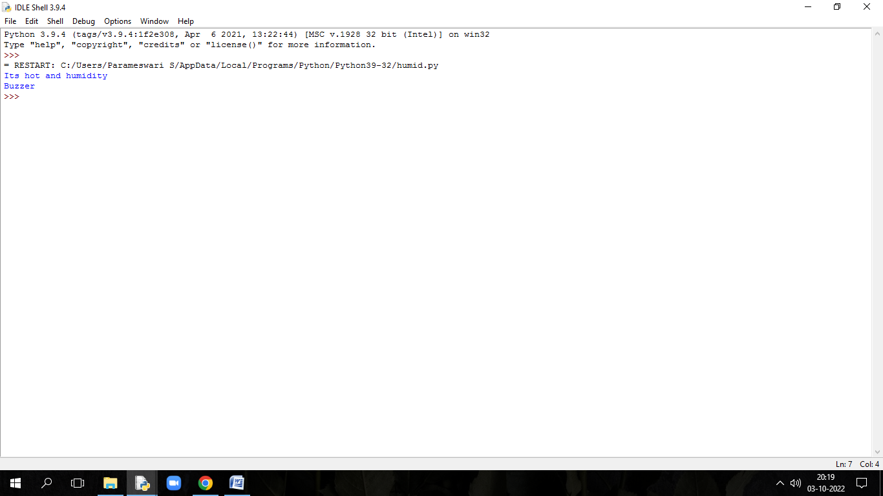

**R.U.Shumin Rakesh**

**961819106049**

**Ponjesly College of Engineering**